 |  | 2026 Beach Classic Tournament  Referee Information Form |  |  |  |  |  |  |  |  |  |  |  |  |  |  |  |  |  |  |  |  |  | 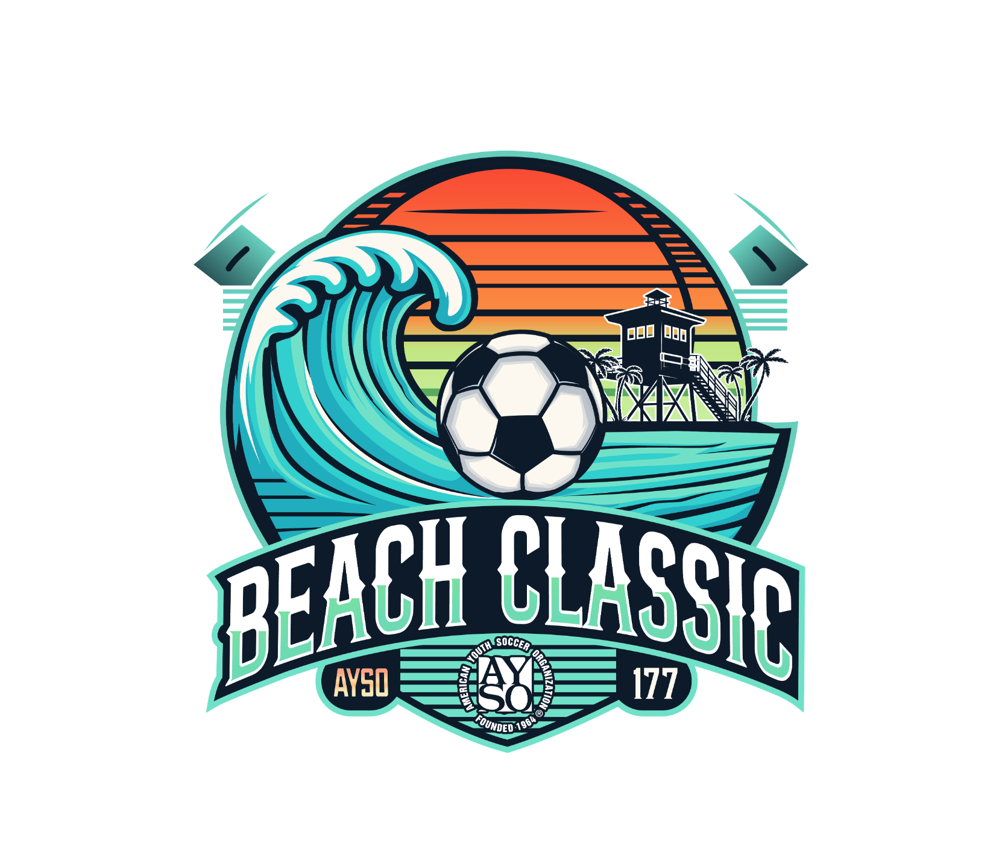
I plan to bring a referee team to the tournament Y/N: |  |  |  |  |  |  |  |  |  |  |  |  |  |  |  | Referee Information Form Date:
Region: |  |  |  |  |  | Team Name:

Coach Name:
Age Division: |  |  |  | U-10 |  |  |  | U-12 |  |  |  |  |  |  |  |  |  |  |  | Boys |  |  | Girls

Referee Team Contact Person
Name: |  | Email Address:
Day Phone: |  | Evening Phone:
Provide the following information for each referee.
- For “Badge Level”, insert R = Regional, I = Intermediate, A = Advanced, N = National. Also the date they were certified at that level.
- In each box under “CR Level” & “AR Level”, provide the highest level they are competent to Center or Assist (B10, G12, etc.)
- In “Player on Team”, indicate if the referee has a child who is playing in the tournament on this team.

 | Referee Name | Badge Level | Cert Date | CR Level | AR Level | Player on Team (Y/N) | Home Phone/ Email
1
2
3

Each referee will receive a tournament T-Shirt. Please indicate sizes needed. All sizes are Adult.
 | S | M | L | XL | XXL | XXXL
Number of Shirts Needed

Regional Referee Administrator’s Name |  | Phone Number |  | Email
By my signature below, I certify that all referees listed are certified AYSO referees and qualified for officiating at the level indicated above.
RRA Signature and date (Blue ink please)

